# QUADMIN compilations notes

## Status

* Compiled windows QUADMIN.EXE and able to execute on personal device
* Determined requirements for compilation
  + On same instance need:
    - Visual C++
    - FAME for Windows (for DLL\header references)
* Execution issues of QUADMIN.exe on STATCAN network
  + Missing VS DLL for running QADMIN on VDI Net B, figure out how and what to register

## Missing steps to operationalize

* Validate results of proof of concept with Michel Chevalier
* Deployment strategy (i.e. determine how to register missing DLLs, or find workaround)
* Elaborate and execute further test cases, for accuracy and performance
* **Effort could be considerable (20+ days) and could require experienced developer / TL to manage**

## Steps to compile and run example case provided by Michel Chevalier in April 2020

### Create visual C++ project in Visual Studio

* Add hilo.c header file (located at "C:\Program Files\FAME\hli.h")
* Add fame path to VC++ properties of Visual Studio instance (reference "C:\Program Files\FAME\readme.txt")
* Add “_CRT_SECURE_NO_WARNINGS” in Preprocessor properties

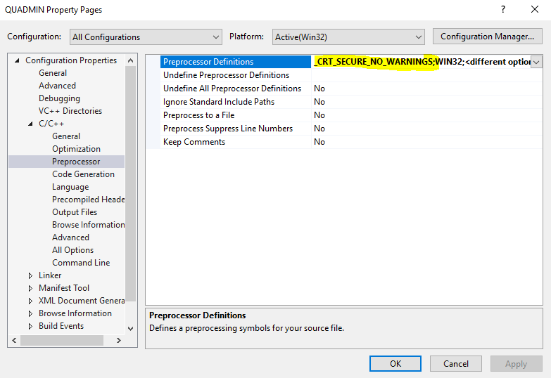

### Include and update quadmin.c file in project

* Around line 50, replace “hilo.h” with <hilo.h>
* Around line 200, comment block related to using CPU (search for “*Restrict the CPU's on which this process can run”*)

### Create FAME for Windows project

* Under input files, add example input project (fame_statmethods.in), for now you can comment all instances of $closeall and $cleanwork (macro available in other procedure files on FAME server, but out of scope for this activity)
* In procedural files, add quadmin.pro and x12.pro files

### Update quadmin.pro file

* Around line 763, change path of QUADMIN executable to compiled EXE (example: *local scalar %path: string = "D:\Project\QUADMIN\QUADMIN\Debug"*

### Execute project

* Right click on both quadmin.pro and x12.pro and select “Compile and Load”
* Right click on fame_statmethods.in and select Input
* You should get x12 errors

## Questions

* Is this sufficient to determine scope of GEESE ?
* Arithmetic functions are complex but well documented on NEAD Network A intranet site, would it be more worth it to spend effort on re-writing these calculations in more modern language then old and deprecated C code (ex: R, Python) ?

# X12 compilations notes

## Status

* Attempted to simply change X12 executable to X13 windows package available on BLS website but getting multiple and different errors on definition of specs
* Need more research on X12 functions and procedures, preferable include help from someone with knowledge of X12arima and X13 packages

## Questions

* GEESE appear to also items to provide interface from FAME to R\Python, since various R and Python X13 wrappers are available, is there any value to spend resources on re-compiling old X13 wrappers for FAME? (reference <https://www.rdocumentation.org/packages/seasonal/versions/1.7.1> and )